MCPIKE MANSION TOURS And EVENTS 2024
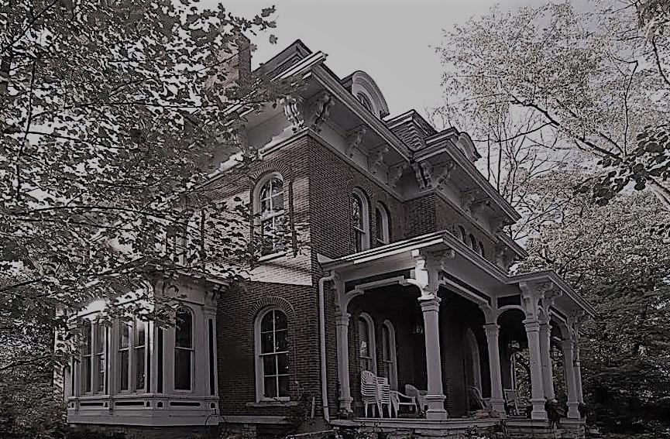
To register for an event or tour and details visit the website http://www.mcpikemansion.com
Help preserve the history of McPike Mansion – 2018 ALBY St. Alton, Illinois
Email sluedke14@gmail.com Or call Sharyn Luedke cell 618 830 2179
Assistance with the 2024 registration calendar text Sandy Little Lizard cell 618 251 9646
2024 TOURS: Tours 7:30pm – Adults $20/Teens $10 / Child $5
Attendees limited to 35 per tour Please Pre-register Early on the website.

Sat April 20th 7:30pm – Honoring Mother Earth tour – Earth Day
Sat May 18th 7:30pm – Armed Forces Day Tour
Sat June 15th 7:30pm – Flag Day / Fathers Day Tour
Sat July 6th 7:30pm – Happy Birthday Henry – Sparklers tour
Sat Aug 10th 7:30pm – Back to school Tour
Sat Sept 7th 7:30pm – Welcoming the Fall tour

OCTOBER TOURS – a Tour every weekend
Friday – Sept 27th 7:30pm – Welcoming the Halloween Season Tour
Saturday- Sept 28th 7:30pm – Hob-knobbing with the Spirits tour
Friday – October 4th 7:30pm – Freaky Friday tour
Saturday – October 5th 7:30pm– Chills and Thrills Tour
Friday-October 11th 7:30pm – Black Cat Crossing Tour
Saturday – October 12th 7:30pm – Gabbing with the Ghosts tour
Friday – October 18th 7:30pm – Ghoul Tour
Saturday – October 19th 7:30pm – Ghost Bustin Tour
Friday – October 25th 7:30pm – Friday Fright Night Tour
Saturday – October 26th 7:30pm – Last Chance Tour

Tours include - history and stories of McPike, tour of the grounds, Dark Session in the Cellar with Medium “Sandy Little Lizard”.

